
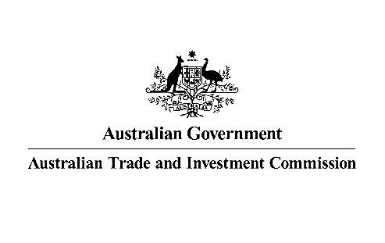

SENIOR Business development manager-AGRiFOOD

Austrade is seeking an experienced professional with strong client focus and established local networks/contacts to join our office which is located within the Australian High Commission in Kuala Lumpur.
Reporting to the Trade and Investment Commissioner Kuala Lumpur, the SBDM is the key business development role assisting Australian businesses in the Agriculture and Food sector in Malaysia & Brunei.
This position requires extensive experience in business development roles within the food and agrifood sectors and demonstrated track record of achieving commercial outcomes. You should have thorough knowledge of market dynamics and trends shaping the food and agrifood sectors, including retail, HORECA, food manufacturing, market regulations, and food supply chain logistics.
Able to demonstrate that you have well-established business networks to identity food and agrifood trade opportunities as well as to the ability to leverage these networks to achieve business results. You should possess excellent presentation and communication skills with the ability to amongst others promote Australia capabilities and products to a broad range of audiences.
You should be strategic, analytical and have problem-solving skills with the proven ability to clearly articulate insights on business opportunities and market trends.
Experience in business planning and successful execution of business plans within a team environment to deliver on KPIs, including high client satisfaction and strategic export outcomes will be advantageous. This role requires you to be able to work effectively and autonomously, in geographically dispersed and culturally diverse teams to achieve shared goals.
You must have strong commitment to professional transparency and integrity with the ability to adhere to the standards and values of Austrade and the Australian Public Service.

As Senior Business Development Manager, you will be responsible for:
- Working as part of the Austrade team to provide professional trade and marketing services to Australian companies looking to enter and expand in Malaysia and Brunei, including:
- working closely with Australian agrifood businesses and industry bodies to determine their needs and help them develop growth strategies in Malaysia and Brunei.
- delivering advice on market conditions and market entry strategies;
- identifying potential business partners and customers;
- advising on government regulatory requirements for food and agri-commodities trade, including packaging requirements and halal certification;
- conducting market research and analysis to identify market trends and business opportunities for Australian companies; and,
- coordinating visit programs and providing in-market support.
- Developing and maintaining deep relationships across food importers, wholesalers, retail, HORECA, food manufacturing, as well as relevant government agencies and industry bodies.
- Delivering events, missions, and campaigns to promote Australia as a reliable, long-term supplier of high-quality, healthy, and innovative food products.
- Working collaboratively with Austrade colleagues both in Australia and across Austrade’s international network, as well as from Australian State and Territory partners.
- Maintaining Austrade standards and policies, including diversity in the workplace, ethical practice and compliance with audit requirements.
- Contributing to the delivery of programs and initiatives that help achieve the ambitious goals of the Australian Government’s Invested: Australia’s Southeast Asia Economic Strategy to 2040Implement Austrade strategies in Malaysia & Brunei in AFC sector by developing and managing relevant initiatives including missions and business-matching activities.
This is a locally-engaged position governed by Malaysian Labour Law and Austrade’s Overseas Engaged Employees Terms and Conditions of Employment. Candidates must be eligible to live and legally work in Malaysia at the time of appointment.
For further details and to apply, please head to our website for the Information Pack and complete the online application form at Austrade - Senior Business Development Manager-Agrifood
Only candidates who complete their application in Austrade’s online recruitment system will be considered.
Applications Close: Sunday 13 July 2025 at 11:30pm (Malaysia time)

