
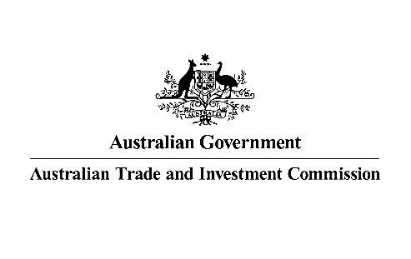

SENIOR INVESTMENT MANAGER

Austrade is seeking an experienced professional with strong client focus and established local networks/contacts to join our office which is located within the Australian High Commission in Kuala Lumpur.
Reporting to the Trade and Investment Commissioner Kuala Lumpur, you should have a demonstrated track record of achieving investment and business outcomes with familiarity in working with trade and investment promotion agencies.
This position requires excellent understanding of the benefits of FDI, how corporate and institutional investment decisions are made and the capacity to understand Australia’s competitive advantages, government policies, and business support programs to attract investment. You should be able to maintain and grow senior business networks and be able to leverage these networks to encourage and facilitate productive FDI into Australia.
Having thorough knowledge of investors from Malaysia and Brunei – including institutions, conglomerates, corporates, family businesses – and the opportunities that interest them as well as their decision maker processes will be advantageous.

You should have excellent presentation and communication skills with the ability to:
  - promote Australia as an attractive destination for FDI to a broad range of audiences
  - brief senior business decision-makers in Malaysia and Brunei about market dynamics, tends, opportunities, and the regulations on foreign investment in Australia
  - communicate complex ideas clearly and coherently, both verbally and in writing, and adapt style to match the audience and the situation
In addition, you should be strategic, analytical and problem-solving skills with proven ability to clearly articulate insights on business opportunities and market trends.
Experience in business planning and successful execution of business plans within a team environment to deliver on KPIs, including high client satisfaction and strategic investment outcomes will be advantageous. This role requires you to work effectively, and autonomously, in geographically dispersed and culturally diverse teams to achieve shared goals.
Strong commitment to professional transparency and integrity with the ability to adhere to the standards and values of Austrade and the Australian Public Service.

As a Senior Investment Manager, you will be responsible for:
- Working with Austrade investment specialists in Australia, and across Southeast Asia, to attract productive foreign direct investment from Malaysia and Brunei into Australia in priorities sectors – green economy, renewable energy, and critical technologies.
- Building strong relationships with investment decision-makers in Malaysia and Brunei and developing deep understanding of their investment priorities and investment strategies.
- Providing advice, connections, and support to facilitate corporate and institutional investment into projects in Australia, as well as to support existing investors.
- Delivering events, missions, and campaigns to promote Australia as an attractive investment destination.
- Supporting visits by Australian corporate and government project proponents and facilitating engagement with potential partners on investment opportunities.
- Developing market insights that can be used to help investors from Malaysia and Brunei to better understand the business and investment environment in Australia.
- Working collaboratively to achieve shared investment and trade outcomes with:
- Austrade investment and sector specialists in Australia and across our international,
- Southeast Asia Deal Teams (supporting Australian investment into Malaysia and Brunei),
- Australian Government agencies, as well as
- Australian State and Territory partners.
- Maintaining Austrade standards and policies, including diversity in the workplace, ethical practice and compliance with audit requirements.
- Contributing to the delivery of programs and initiatives that help achieve the ambitious goals of the Australian Government’s Invested: Australia’s Southeast Asia Economic Strategy to 2040.
This is a locally-engaged position governed by Malaysian Labour Law and Austrade’s Overseas Engaged Employees Terms and Conditions of Employment. Candidates must be eligible to live and legally work in Malaysia at the time of appointment.
For further details and to apply, please head to our website for the Information Pack and complete the online application form at Austrade - Senior Investment Manager
Only candidates who complete their application in Austrade’s online recruitment system will be considered.
Applications Close: Sunday 20 July 2025 at 11:30pm (Malaysia time)

